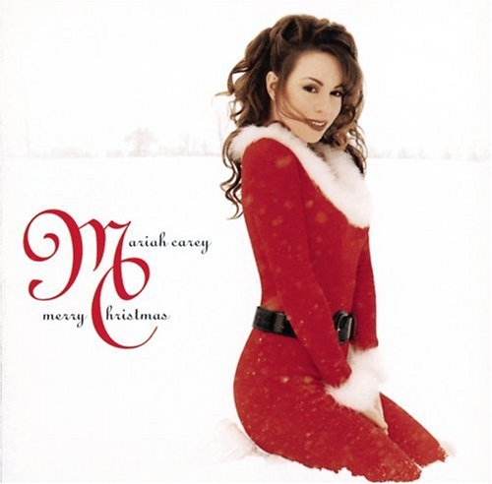
Mariah Carey - All I Want For Christmas Is You

1) Most people say that Christmas is their favourite holiday? Why do they say so?

2) Complete the gaps with the words from the box.
mistletoe tree the North Pole reindeer stocking sleigh

I don't want a lot for Christmas
There is just one thing I need
I don't care about the presents
Underneath the Christmas 1) ................................
I just want you for my own
More than you could ever know
Make my wish come true
All I want for Christmas is
You ...
I don't want a lot for Christmas
There is just one thing I need
(and I) Don't care about presents
Underneath the Christmas tree
I don't need to hang my 2) …………………
There upon the fireplace
Santa Claus won't make me happy
With a toy on Christmas day
I just want you for my own
More than you could ever know
Make my wish come true
All I want for Christmas is you...You baby
Oh I won't ask for much this Christmas
I won't even wish for snow
(and I) I'm just gonna keep on waiting
Underneath the 3) ............................

I won't make a list and send it
To 4)......................for Saint Nick
I won't even stay awake to
Hear those magic 5)............................click
'Cause I just want you here tonight
Holding on to me so tight
What more can I do
Baby all I want for Christmas is you
You baby
Oh all the lights are shining
So brightly everywhere (so brightly baby)
And the sound of children's
Laughter fills the air
And everyone is singing
I hear those6)........................bells ringing
Santa won't you bring me the one I really need -
won't you please bring my baby to me...
Oh I don't want a lot for Christmas
This is all I'm asking for
I just want to see my baby
Standing right outside my door
Oh I just want you for my own
More than you could ever know
Make my wish come true
Baby all I want for Christmas is
You
All I want for Christmas is you baby...

Abba - Happy New Year

1) How do you usually celebrate New Year?

2) Complete the gaps with the words from the box.

Listen to the song and check.

confetti neighbour decade seems thinks champagne

No more 1)................................
And the fireworks are through
Here we are, me and you
Feeling lost and feeling blue
It's the end of the party
And the morning2) ............so grey
So unlike yesterday
Now's the time for us to say
Chorus:
Happy new year
Happy new year
May we all have a vision now and then
Of a world where every 3)..................... is a friend
Happy new year
Happy new year
May we all have our hopes, our will to try
If we don't we might as well lay down and die
Chorus.
Sometimes I see
How the brave new world arrives
And I see how it thrives
In the ashes of our lives
Oh yes, man is a fool
And he 4).................he'll be okay
Dragging on, feet of clay
Never knowing he's astray
Keeps on going anyway...
Chorus.
Seems to me now
That the dreams we had before
Are all dead, nothing more
Than 5)...................on the floor
It's the end of a 6)......................
In another ten years time
Who can say what we'll find
What lies waiting down the line
In the end of eighty - nine...
You and I

Find English equivalents for the words in bold:

глина-…………………………………..
грусть/грустный-…………………………………..
пепел-……………………………..
заблудившийся, сбившийся с пути –……………………………..
процветать -……………………………..
влачить (существование) -……………………………..
закончиться-……………………………..

