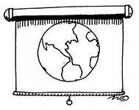
COUNTRIES AND CONTINENTS
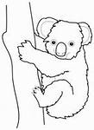
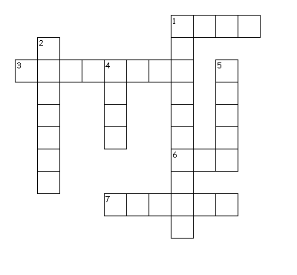
Across
1. Hello! I’m Jessica Gram. I’m………… Canada. I live in Toronto.
3 India is …………………………in Asia.
6 Michael speaks English. He’s from ……USA.
7 Australia is ……………………………for unusual animals, such as kangaroos and koalas.
Down
1. I’m from St. Petersburg. It’s in the Russian ………………………….
2. People believe that Santa Claus lives in …………………………….. It’s a country in the north of Europe.
4. China is in……………………….. (continent)
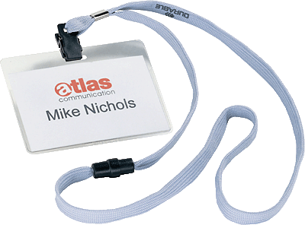
5. Here’s your ……………….

ANSWERS
Across
1 from
3 situated
6 the
7 famous
Down
1 Federation
2 Finland
4 Asia
5 badge

